ACC. Coordinate Algebra Name _____________________
Perpendicular Bisectors & Circumcenter

1. What does the Perpendicular Bisector Theorem state? If a point is on the perpendicular bisector of a segment, then it is equidistant from the endpoints of the segment.
2. Where is the circumcenter of a triangle located? And what is the significance of it? The circumcenter can be located inside (acute), outside (obtuse) or on (right) a triangle. It is located at a point that is equidistant from each of the vertices.

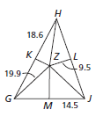
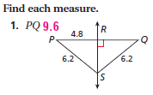
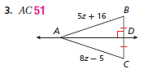
3. 4.

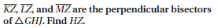
5.

See your notes.

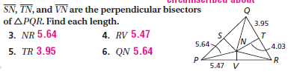
6.

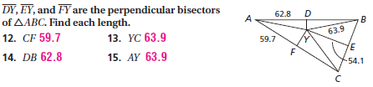
7.

Write the equation in slope-intercept form for the perpendicular bisector of the segment with the given endpoints.
8. (-3, -1) and (7, -5) 9. (6, -5) and (10, 1)
Midpoint (2, -3) Midpoint (8, -2)
Slope -2/5 5/2 Slope 3/2 -2/3
Point Slope: y - (-3) = 5/2 (x – 2) Point Slope: y – (-2) = -2/3 (x – 8)
Slope Intercept: y = 5/2x – 8 Slope Intercept: y = -2/3x + 10/3

