Accelerated Coordinate Algebra Name________________________
Spring 2016—Benchmark 2—Study Guide –Day 2

Be sure to review previous tests, quizzes, assignments and notes!!!

- Find the sum of the interior angles of a convex dodecagon.

- What is the measure of one interior angle of a regular 15-gon?

- What is the sum of the measures of the exterior angles of a regular decagon?

- What is the measure of one exterior angle of regular 18-gon?

- Find the measures of the numbered angles in the rhombus.
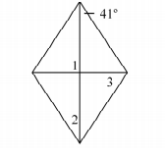
- Given rectangle PQRS, PR= 18x - 24 and QS = x + 146. Find the value of x and the length of the diagonals.
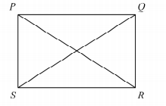

- Always, Sometimes or Never.
- The diagonals of a parallelogram are congruent.
- All rectangles are squares.
- A square is a rhombus.

